The Tucker Middle School Symphonic Orchestra
Tuesday, October 24, 2017
Dr. Kathy Cunningham, Principal
Robert Rieve, Orchestra Director

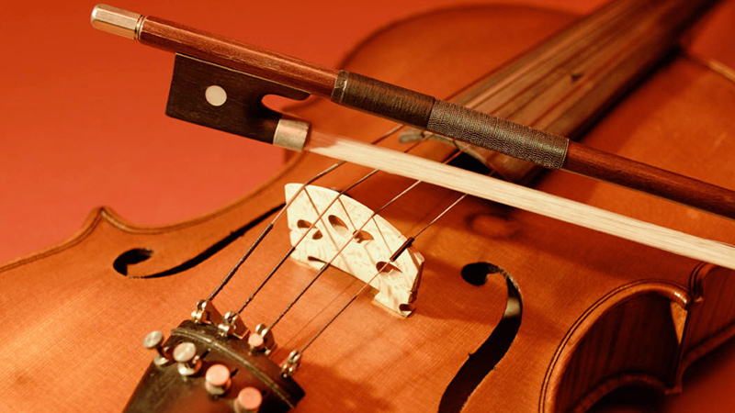

La Rejouissance……………………………….G. F. Handel (1685-1759)

Dona Nobis Pacem (Grant Us Peace)...................Anonymous
Guest narrators, Dr. Kathy Cunningham and Mr. Christopher Smith

Brandenburg Concerto #3 Mvt. 1……………...J. S Bach (1685-1750)
Concerto in D Major…………………………...J.S. Bach
Cripple Creek…………………………………..Arr. Edmund Siennicki

Program notes

La Rejouissance
Composed by George Friedrich Handel in 1749, La Rejouissance or the rejoicing, is the 4th movement of Handel’s Music for the Royal Fireworks. Music for the Royal Fireworks was composed to celebrate the the end of the War of Austrian Succesion and was first performed on April 27, 1749 in London’s Green Park.

Dona Nobis Pacem (Grant Us Peace)
The origins of this melody, sung as part of the Latin mass, are unknown. The words are sung as a canon. The Tucker Middle School Symphonic Orchestra would like to dedicate this piece to the victims of the October 1rst shooting in Las Vegas.

Brandenburg Concerto #3
Johann Sebastian Bach composed 6 Brandenburg Concerti dedicated to Christian Ludwig of Brandenburg Schwegt. This collection of works was written by Bach as part of a “portfolio” for his potential employer neither earned Bach a job or a performance of the works! This 3rd concerto, one of the most popular of the 6 concerti, has been arranged numerous times for various musical ensembles.

Concerto in D
Based on the Violin Concerto #3 in E major, this work was re-used by Bach as his Harpsichord Concerto in D. This arrangement by Merle Isaac is a popular version of the concerto performed quite frequently by middle and high school orchestras across the country.

Cripple Creek
Cripple Creek is a traditional tune written by Edmund Siennicki, an American composer, educator, and conductor. The piece depicts the small rustic mining town of Cripple Creek, Colorado. While living in Colorado, this was one of our favorite towns to visit on a Saturday afternoon.

